**DEVELOPMENT PHASE PART 2**

**WATER QUALITY ANALYSIS**

|  |  |
| --- | --- |
| **Date** | 24-10-2023 |
| **Team ID** | 1278 |
| **Project Name** | Water Quality Analysis |

**Table Of Content:**

1.Introduction.

2.Data Preprocessing.

3.Data Visualization.

3.1. Histogram & Distribution.

3.2. Boxplot.

3.3. Scatter Plots.

3.4. Correlation Heatmap.

4.Data Splitting.

5.Predictive Model.

6.Conclusion

**1.Introduction:**

In the development part 2 the project is Continued building the analysis by creating visualizations and building a predictive model. Using visualization libraries like Matplotlib, Seaborn the histograms, scatter plots, and correlation matrices were created. A predictive model is built to determine water potability based on water quality parameters.

**2.Data Preprocessing:**

In the previous phase the Data processing which is essential in data analysis to increase data quality. Data processing is described as “the collection and manipulation of data components to produce meaningful information.” Through meticulous handling of missing values, dynamic feature scaling, and real-time outlier detection, the dataset attained a level of precision essential for accurate predictions. The data preprossing is done by using Jupyter notebook .

# 3.Data visualization:

# 3.1. Histogram & Distribution.

def show_distributions(columns: list, data: pd.DataFrame, nrows: int = 1, ncols: int = 3):  
 # This function creates distribution subplots.  
 fig, axes = plt.subplots(nrows=nrows, ncols=ncols, figsize=(15, 5))  
 axes = axes.ravel()  
 for index, column in enumerate(columns):  
 sns.histplot(data[column], kde=True, ax=axes[index])  
 axes[index].set_title(column)  
  
 # Adjust layout  
 plt.tight_layout()  
 plt.show()  
show_distributions(data.columns[:-1], data,3,3)

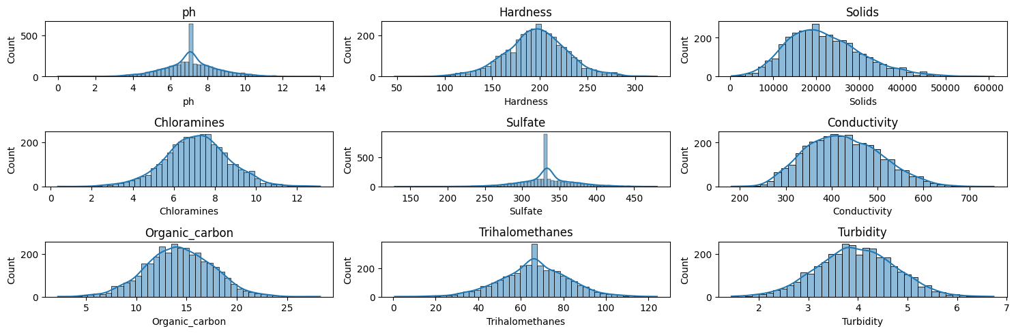

# 3.2.Boxplot

features_num = ['ph', 'Hardness', 'Solids', 'Chloramines', 'Sulfate',  
 'Conductivity', 'Organic_carbon', 'Trihalomethanes',  
 'Turbidity']  
for f in features_num:  
 fig, (ax1, ax2) = plt.subplots(2, 1, figsize=(10,6), sharex=True)  
 ax1.hist(data[f], bins=30)  
 ax1.grid()  
 ax1.set_title(f)  
 # for boxplot we need to remove the NaNs first  
 feature_wo_nan = data[~np.isnan(data[f])][f]  
 ax2.boxplot(feature_wo_nan, vert=False)  
 ax2.grid()  
 ax2.set_title(f + ' - boxplot')  
 plt.show()

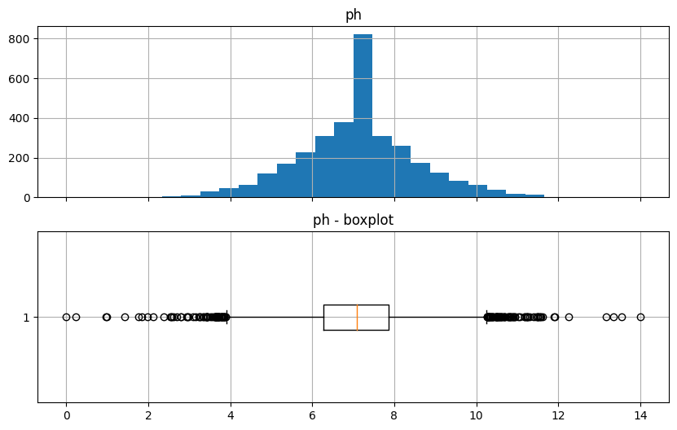

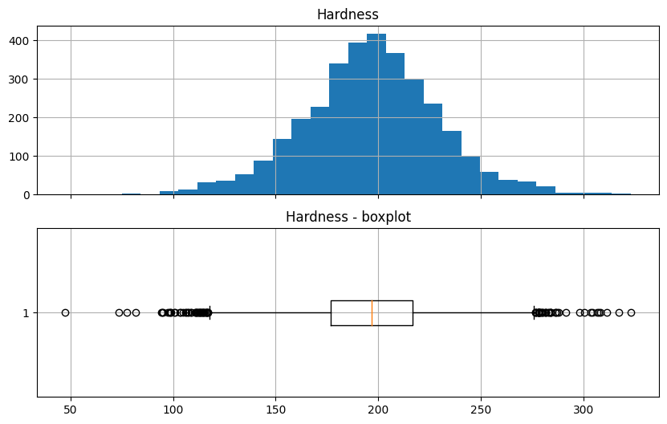

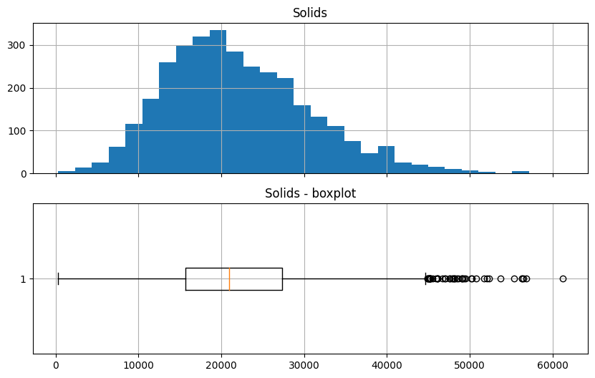

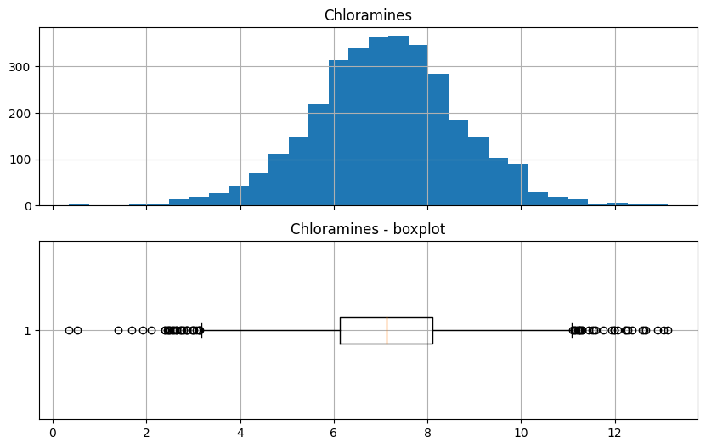

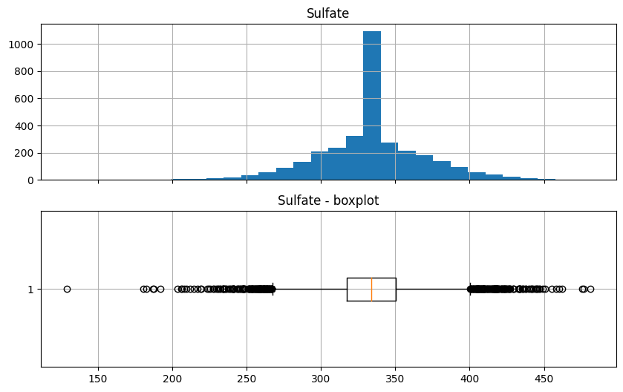

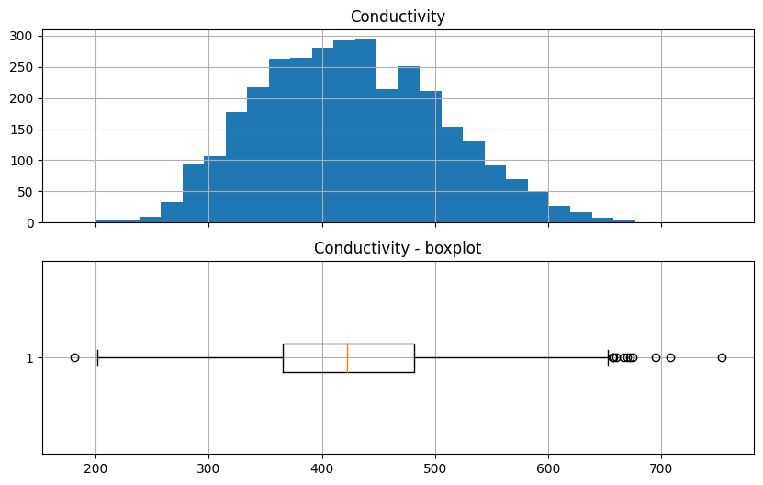

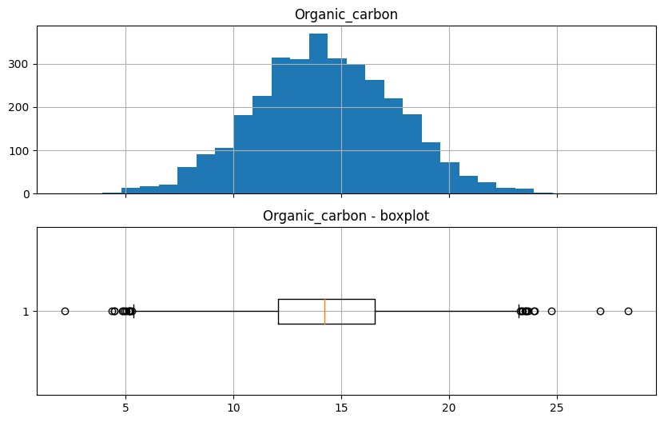

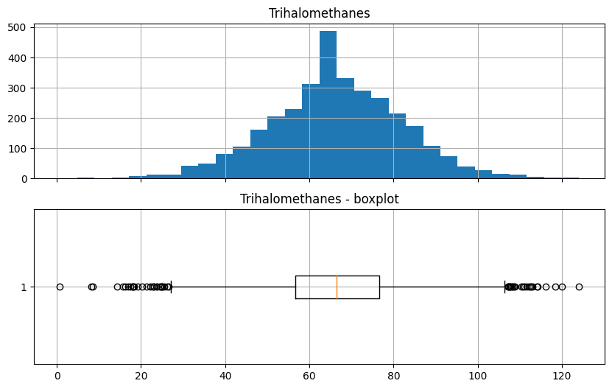

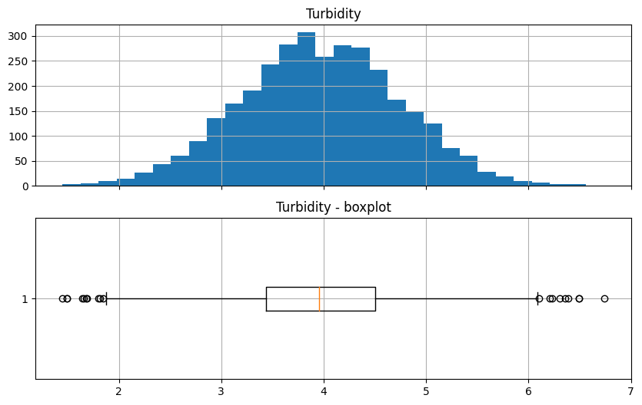

# 3.3. Scatter Plots.

sns.pairplot(data=data,hue="Potability")

<seaborn.axisgrid.PairGrid at 0x7e0550701060>

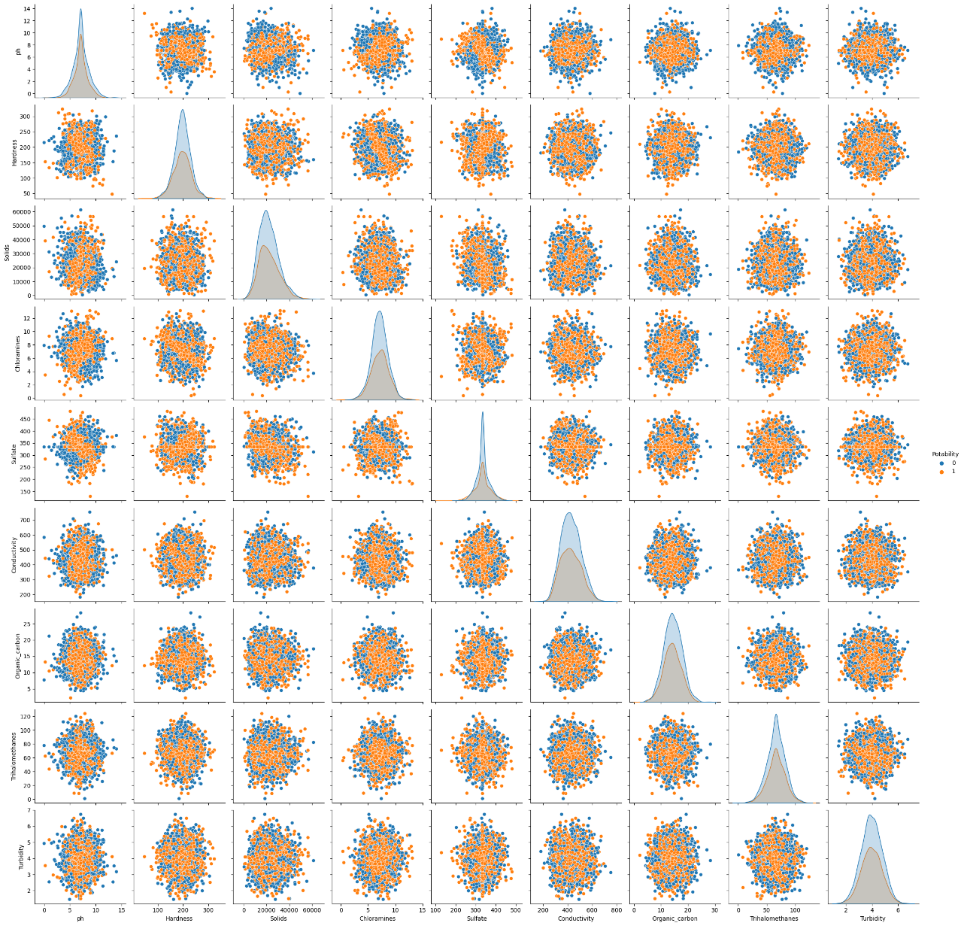

# 3.4. Correlation Heatmap.

corr_mat = data.corr()  
fig, ax = plt.subplots(figsize=(15,10))  
ax = sns.heatmap(corr_mat,annot=True,linewidths=0.5,fmt='.3f',cmap='YlGnBu')

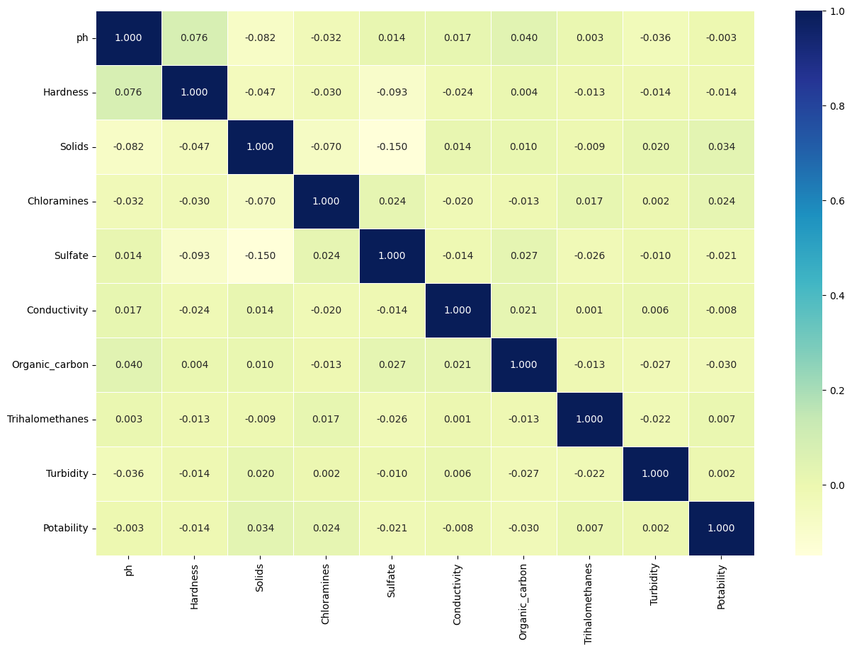

# 4.Data Splitting.

sm = SMOTE(random_state=42)  
  
X, y = data[data.columns[:-1]], data["Potability"]  
X, y = sm.fit_resample(X, y)  
from sklearn.preprocessing import Normalizer, StandardScaler  
X_train, X_test, y_train, y_test = train_test_split(X, y, test_size = 0.25)

#5. Predictive Model.

models = [RandomForestClassifier()]  
pipelines = {}  
for model in models:  
 model_name = str(model.__class__).split(".")[-1].split("'")[0]  
 pipe = Pipeline([  
 ("scaler", StandardScaler()), # Preprocessing step  
 ("classifier", model) # Classifier step  
 ])  
 pipelines[model_name] = pipe  
  
  
for name,pipe in pipelines.items():  
 print(f"Training {name}")  
 scores = cross_val_score(pipe, X_train, y_train, cv = 5, scoring = "accuracy")  
 print(f"Mean Score {scores.mean()} -- Std {scores.std()} -- Min {scores.min()} -- Max {scores.max()}")  
 pipe.fit(X_train, y_train)

Training RandomForestClassifier  
Mean Score 0.6740100166944908 -- Std 0.01986394725623316 -- Min 0.6427378964941569 -- Max 0.7028380634390651

*5.1.Hyperparameter tuning the RandomForest model.*

param_grid = {  
 "criterion": ["gini", "entropy", "log_loss"],  
 'n_estimators': [10, 20, 30, 40,50],  
 'max_depth': [5, 10, 20, 30, 50],  
}  
  
rf_classifier = RandomForestClassifier(random_state = 42)  
scorer = make_scorer(accuracy_score)  
grid_search = GridSearchCV(  
 rf_classifier, param_grid, scoring=scorer, cv=5, verbose = 1  
)  
grid_search.fit(X_train, y_train)  
best_rf = grid_search.best_estimator_  
  
best_predictions = best_rf.predict(X_test)  
best_accuracy = accuracy_score(best_predictions, y_test)  
  
print("Best Accuracy Score:", best_accuracy)

Fitting 5 folds for each of 75 candidates, totalling 375 fits  
Best Accuracy Score: 0.6866866866866866

*5.2.RandomForest model Accuracy Score.*

accuracy_score(best_rf.predict(X_test),y_test)

0.6866866866866866

*5.3.Confusion Matrix*

plt.figure(figsize=(10,5))  
sns.heatmap(confusion_matrix(best_rf.predict(X_test),y_test), annot = True,fmt='.1f')  
plt.ylabel("Actual")  
plt.xlabel("Predicted")  
plt.title("Confusion Matrix")  
plt.tight_layout()

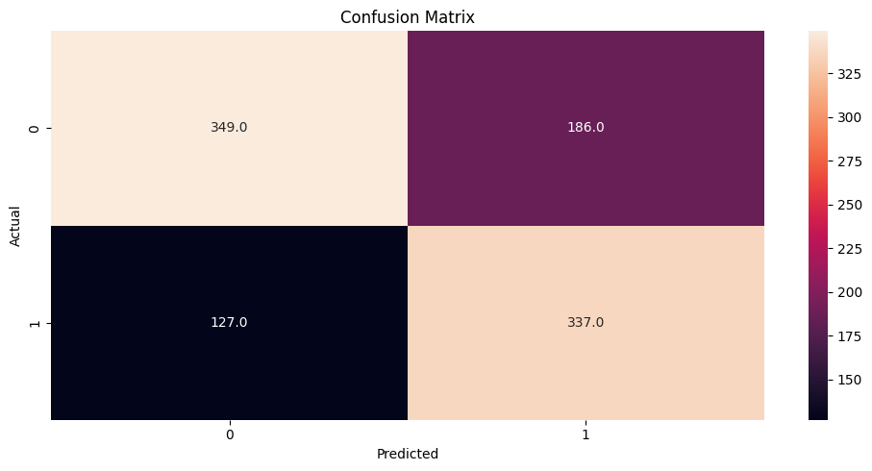

**6.Conclusion:**

Thus, in this document the project is Continue building the analysis by creating visualizations and building a predictive model. Using visualization libraries like Matplotlib, Seaborn the histograms, scatter plots, and correlation matrices were created. The Random Forest Classifier, trained on pre-processed water potability data, demonstrates robust performance with an accuracy of approximately 74%. Despite complexities in the dataset, the model showcases reliable predictive power, making it a suitable choice for potability prediction.